Systematic Position:
Phylum – Protozoa
Sub – phylum – Plasmodroma
Class – Mastigophora
Order – Protomonadina
Family – Trypanosomidae
Genus – Trypanosoma
Species – Gambiense
Trypanosoma gambiense is a protozoan haemoflagellate endoparasite of man inhabiting the blood, lymph and the intercellular spaces of different tissues and organs of man. Hogs, goats, cattle and sheep are potential reservoir hosts.
The parasite causes a disease called Gambian or West-African sleeping sickness in human-beings. The disease African sleeping sickness was first described by Atkins in 1724 and Winterbottom in 1803, but the causative parasite was described in human blood by Forde in 1901 and later on named as T. gambiense by Dutton in 1903.

Geographical distribution:
T. gambiense are found in West and Central Africa between 15° N and 15° S latitude. In Western part of Africa it is found between Senegal and Angola. Other endemic areas are Congo, Niger and Southern Sudan. Their distribution depends upon the areas where the vector of the parasite, Glossina palpalis actually exists.

Life cycle:
T. gambiens are digenetic parasites, completing their life cycle in two hosts. The primary or definitive hosts are human-beings, whereas the secondary or intermediate hosts are tsetse fly (Glossina palpalis).
T. gambiense exits in their vertebrate host (man) as a trypomastigote form. They live freely in the blood and in the intercellular spaces of lymph nodes and brain. At later stage they appear in the cerebrospinal fluid, spinal cord and brain. The parasite, in man, appears as elongated spindle shaped unicellular protozoan, measuring 15 µ to 30 µ in length and 1.5 µ to 3 µ in breadth.
The posterior end is blunt while the anterior end is pointed. A single large oval nucleus lies in the middle of the body with a central karyosome. The nuclear membrane is clearly distinct. Near the posterior end is a disc shaped kinetoplast.
Kinetoplast is about 1 ц in size and consists of a rod shaped parabasal body and a small granule like blepharoplast. A single flagellum originates from near kinetoplast. Flagellum curves around the body in the form of an undulating membraneand finally project out through the anterior end as a free flagellum.
The undulating membrane through its course form 3 to 4 folds, Trypanosomes are actively motile. The wavy movement is produced by contractive flagellum and undulating membrane. Nourishment is obtained from blood plasma, lymph, cerebrospinal fluid and the products of cellular disintegration of the host.
T. gambiense show the phenomenon of polymorphism. A single parasite during its different stages in human body exhibits variable shape and size. Three main forms are –
(a) Elongated, spindle shaped form with free flagellum.
(b) Stumpy form without free flagellum.
(c) Intermediate form.
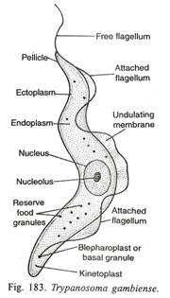
The infective form (metacyclic stage) of the parasite, when enters into the body of the definitive host as a result of the bite of infected Glossina (Tsetse fly), first develop into long, slender form. It immediately starts multiplying in number by longitudinal binary fission. Later on they are transforms into stumpy form passing through a short intermediate form.
Stumpy forms are thick and short, measuring about 10 µ in length and 5 µ in breadth, without free flagellum. The stumpy form parasite then enters into the lymphatics and blood stream resulting in parasitaemia. When a tsetse fly of either sex bite an infected man, the trypomastigote form particularly the short stumpy form enters into the gut of the intermediate host along with blood meal.
When the stumpy form of trypomastigote (trypanosoma) reaches the mid gut of tsetse fly, it undergoes morphological changes. The body becomes long and slender, the kinetoplast moves near the nucleus in the posterior half and undulating membrane becomes less pronounced with a free flagellum.
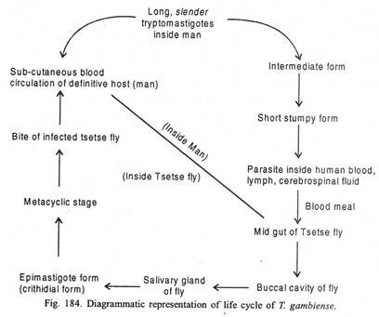
Within two days, after the fly has sucked infected blood, the parasite begins to multiply in the lumen of the mid gut. They do so up to 15th day and then migrate to the proventriculus. The parasite moves forward passing through oesophagus, buccal cavity, hypopharx sahvary duct finally reaches the salivary gland of the intermediate host. Inside salivary gland the trypanosomes attach themselves to the wall of gland by means of their long flagellum and get transformed into the epimastigote (crithidial form).
After multiplying there for 2 to 5 days epimastigotc changes into met-acyclic stage. These are short stumpy forms with or without free flagellum Meta-cyclic trypomastigote is the infective form for man. Time taken to reach the infective stag in tsetse fly is 20 to 21 days.
The fly remain infective for their whole life (i.e., approximately 185 days). When an infected tsetse fly bites a man, the parasite is inoculated into the body of the definitive host to repeat the life cycle.

Mode of infection:
The mode of infection is inoculative. The infected tsetse fly Glossina palpalis, of either sex, when bites a man in order to suck blood transmit the infective stage parasite to the new definitive host. The meta-cyclic stage of the parasite along with the saliva о the fly reaches the sub-cutaneous blood of the host.
Pathology:
The incubation period is usually about two weeks but it may be longer in persons having fair degree of resistance. The disease caused due to this parasite is commonly known as “sleeping sickness”. Following are the important pathological conditions arising during the disease.
1. The first sign of the disease is restlessness and disturbance of the sleep, remittent fever with wide diurnal fluctuation, persistent headache, edema, dyspnea, disturbed vision edematous swelling around eyes and joints, pain in joints and muscles, weakness, cutaneous allergic etc.
2. In the early phase of the disease, there is general enlargement of lymphatic gland which later on becomes firm and fibrous.
3. The perivascular infiltration causes various psychic, motor and sensory disturbances.
4. There is severe damage of the perivascular connective tissues as the collagen fibres are disrupted and the fibroblasts are destroyed.
5. Leucocytosis and anaemia occurs. Due to high rise of gamma globulin the ESR is raised and serum aldehyde test become positive.
6. Auto-agglutination of red blood cells occur.
7. In the chronic stage (cerebrospinal stage) of the disease which begins from the early second year, the patient becomes dull and drowsy. The patient even falls asleep even in the mi s of the activity. In the terminal stage, the patient passes into almost continuous sleep.
A patient suffering from Gambian sleeping sickness, if not treated is destined to die. Death occurs from coma, dehydratin, asthenia, convulsion and pneumonia.

Treatment:
In early infection drugs like suramin and pentamidine are used. In later stages when central nervous system is involved arsenicals like tryparsamide, melarsen and tnmelarsen are being used. Nitrofurazone (fiiracin) may be used in certain cases.
Prophylaxis:
Following are the prophylactic measures:
1. Destruction of the habitat of the vector.
2. Destruction of the vector by the use of insecticides.
3. Isolation of human population from areas harbouring the vector.
4. A single intramuscular injection of 4 mg/kg may be used as chemo-prophylactic measure, which remains effective for six months.

LIFE CYCLES
Insects are usually involved in the natural transmission of the African pathogenic trypanosomes with which we are concerned in this field guide. When this is the case, the life cycle has two phases, one in the insect vector and one in the mammalian host. Transmission by insects may be cyclical by tsetse flies,³ Glossina species, or mechanical by other biting flies (but apart from transmitting trypanosomes cyclically, tsetse flies can also act as mechanical vectors).
³ We assume that the reader has some knowledge of tsetse flies, as there simply is no scope in this manual for going into details. At present 23 different species and eight subspecies of the genus Glossina are recognized, belonging to three groups: fusca group or forest group, palpalis group or riverine group, and morsitansgroup or savannah group.

Cyclical transmission
When a tsetse fly hatches from its pupal case it is free from trypanosomes. Until its first bloodmeal, it is called a teneral fly. It acquires a trypanosomal infection when feeding on a parasitaemic (= having parasites in the circulating blood) mammalian host. The trypanosomes undergo a cycle of development and multiplication in the digestive tract of the fly until the infective metacyclic trypanosomes (metatrypanosomes) are produced. As indicated in Table 1 (p. 32), different trypanosome species develop in different regions of the digestive tract of the fly, and the metatrypanosomes occur either in the biting mouthparts or the salivary glands. The period from ingesting infected blood to the appearance of these infective forms varies from one to three weeks; once infective metatrypanosomes are present the fly remains infective for the remainder of its life. During the act of feeding the fly penetrates the skin with its proboscis. By the rupture of small blood vessels a pool of blood is formed in the tissues and the fly injects saliva to prevent coagulation. Infection of the host takes place at this stage, with infective metacyclic trypanosomes in the saliva.
Although no classical sexual processes in the life cycle of trypanosomes have been described, it has been shown that exchange of genomic material (DNA) between trypanosomes sometimes occurs in the tsetse fly, although it is not clear how significant this is.
Life cycle in the mammalian host. The infective metatrypanosomes undergo development and multiplication at the site of infection where a swelling or chancre may be detected in the skin, and finally the mature blood trypanosomes (or trypomastigotes) are released via lymph vessels and lymph nodes into the blood circulation.
Reproduction in the mammalian host occurs through a process of binary division, details of which are described in Morphology, p. 14.
Trypanosomes feed by absorbing nutrients, through their outer membrane, from the body fluids of the host. The proteins, carbohydrates and fats are digested by enzyme systems within their protoplasm. Oxygen dissolved in the tissue fluids or blood plasma of their host is absorbed in a similar manner, to generate the energy necessary for the vital processes.
Waste products are disposed of by a reverse process, through the outer membrane, into the body fluids of the host. They include carbon dioxide formed during respiration, as well as more complex metabolic products.
Life cycle in the tsetse fly. The site of the different trypanosome species in the fly is indicated in Table 1. Blood stream forms (trypomastigotes) ingested by the fly undergo considerable changes, in morphology as well as in their metabolism. They change into long slender forms called epimastigotes, which multiply and finally give rise to the infective metatrypanosomes. For a detailed account of the different forms and the development in the tsetse fly, the reader is referred to standard text books (see Further reading on p. 157).

Mechanical transmission
By biting insects. The process is purely mechanical. A biting insect passes the blood forms from an infected animal to another in the course of interrupted feeding. The time between the two feeds is crucial for effective transmission because the trypanosomes die when the blood dries. The importance of this mode of transmission is variable from place to place, depending on the numbers of hosts and biting insects present, and also on the species of trypanosome. Large biting insects such as tabanids carry more blood and are more likely to act as mechanical vectors than for example mosquitoes. (Tsetse flies themselves can of course also act as mechanical vectors.) This mode of transmission has proved to be sufficiently effective to maintain Trypanosoma vivax and Trypanosoma evansi in South and Central America, and the latter species in North Africa and Asia as well. No tsetse flies occur outside tropical Africa, apart from small tsetse pockets in the southwest of the Arabian peninsula.
By iatrogenic⁴ means. This can occur when using the same needle or surgical instrument on more than one animal, at sufficiently short intervals that the blood on the needle or instrument does not dry. It is not an uncommon occurrence when animals are vaccinated or treated by injection, or when blood is collected from several animals in a row, without changing or disinfecting needles or pins. It may also occur when several animals are subjected at short intervals to a surgical intervention (dehorning, castration, etc.) without properly disinfecting the instruments.
⁴ Iatrogenic transmission means that it is caused by the (veterinary) operator. Iatrogenic infections are induced (involuntarily) by the operator using unhygienic procedures, such as contaminated instruments.

Transmission by other means
- It is well known that carnivores may be infected with T. evansi and T. brucei by ingesting meat or organs from infected animals, as long as these are still sufficiently fresh to contain live trypanosomes. Infection occurs probably through the mucosa of the mouth (in which moreover bone splinters make wounds through which the parasites penetrate even more easily).
- Transmission of T. evansi in Latin America by the bites of vampire bats is common. These bats become infected by ingesting blood from infected horses or cattle, the trypanosomes multiply in the bats and these are thereafter able to transmit the disease to healthy animals. The trypanosomes apparently pass readily through the oral mucosa of the bat in both directions.
- All trypanosome species are occasionally transmitted congenitally, from the mother to the offspring, either through the placenta while the foetus is still in the uterus, or when bleeding occurs during birth. Congenital transmission of T. vivax, for example, has been observed in Latin America as well as in Africa, but its real importance is not well known.
- Venereal transmission is the normal means by which dourine of equines, caused by Trypanosoma equiperdum, is propagated. Because of its presence in the mucous exudate of penis and sheath of the stallion and the vaginal mucus of the mare, T. equiperdum is easily transmitted directly during copulation from an infected to a healthy animal and its geographical distribution is not restricted to specific climatic conditions. This species is essentially a tissue parasite and causes at most very low parasitaemias in the circulating blood of equines.

MORPHOLOGY
A sound knowledge of the basic features of the various trypanosomes enables the identification of each species and so the exact cause of the disease. Once the basic features possessed by all trypanosomes are appreciated, the diagnostic differences can be recognized and the species identified.

Basic morphology of trypanosomes.
Figure 1 is a diagrammatic illustration of the fundamental features of a trypanosome (trypomastigote) as seen in a stained preparation made from the blood of an infected animal.
Figure 1
Diagram of a trypanosome
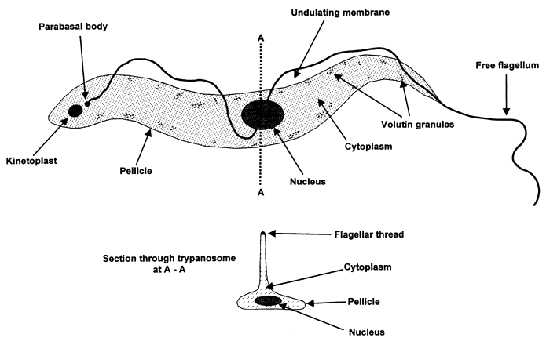
The parasite consists of a single cell varying in size from 8 to over 50 μm.⁵ All the activities associated with a living organism take place within this unicellular organism — nutrition, respiration, excretion, reproduction. The substance of which all living cells consist, the protoplasm, comprises three parts, an outer protective and retaining layer, the pellicle = cell envelope = cell membrane, within which the cytoplasm forms the bulk of the contents. Suspended in the cytoplasm are various structures, the most prominent being the nucleus, which may be regarded as the command centre of the cell and which also plays a major part in reproduction. It contains DNA (deoxyribonucleic acid), which is arranged in the form of genes and chromosomes; it represents the genetic information and is responsible for the manufacture of enzymes and other proteins of the cell.
Small granules (formerly called “volutin granules”) can sometimes be seen in the cytoplasm; they may have various origins, they may be food or nuclear reserves, or result from a reaction between the trypanosome and the host's immune system.
Trypanosomes are thoroughly adapted to living and moving in the blood plasma or tissue fluid of the host. They are elongated and streamlined, and tapered at both ends. The pellicle, the outer layer of the cytoplasm, is flexible enough to permit a degree of body movement, while retaining a definite shape. As shown in Figure 1, a flagellum arises near to the posterior end from a parabasal body, and runs the length of the trypanosome; it may be continued beyond the anterior end of the body as a whip-like free flagellum. Along the length of the body the pellicle and cytoplasm are pinched up into a thin sheet of tissue called the undulating membrane, through the outer margin of which runs the flagellum, as shown in Figure 1.
Among other basic morphological features, a distinct well-defined body, the kinetoplast, is seen near to the posterior end of the trypanosome and differs in size and position according to the species. It is adjacent to the parabasal body (from which the flagellum arises), and so close to it that it cannot easily be seen separately with the light microscope. The kinetoplast has important functions in reproduction and metabolism and is probably essential for cyclical transmission by tsetse flies. (It is sometimes absent in a proportion of.trypanosomes, especially of some strains of T. evansi, a species which has lost its ability of being cyclically transmitted.) The extent of the undulating membrane and the absence or presence of the free flagellum are also precious in specific identification of trypanosomes. Other morphological characters are the average length and the shape of the body.
⁵ One μm is a micron, a millionth of a metre or a thousandth of a millimetre.

Locomotion
Trypanosomes move actively and progress by movement of the undulating membrane and the free flagellum (when present), which acts as a kind of propeller, thus drawing themselves through the blood plasma or tissue fluid. (The free flagellum, when present, arises from the anterior [front] end of the parasite.) The movement pattern as seen with the microscope in fresh blood preparation can be of some help in identifying the species involved, particular for Trypanosoma vivax, which moves rapidly forward between the blood cells, whereas other species often just wriggle around without showing much forward progress.

Reproduction
This is by a process of division to produce two daughter cells. However, as stated above, it has been shown that exchange and recombination of genetic material may take place in the tsetse fly between two trypanosomes, but it is unknown how frequently this occurs.
The division into two daughter cells (binary fission) follows the sequence of events illustrated in Figure 2. The kinetoplast divides first. A second parabasal body develops, from which a second flagellum develops. The nucleus divides next, followed by the rest of the trypanosome body duplicating all the structures present in the cytoplasm. The body then divides into two daughter cells, beginning at the anterior end. The process is rapid, and may result in a vast population in the host within a short period of time.
Figure 2
Division of a trypanosome
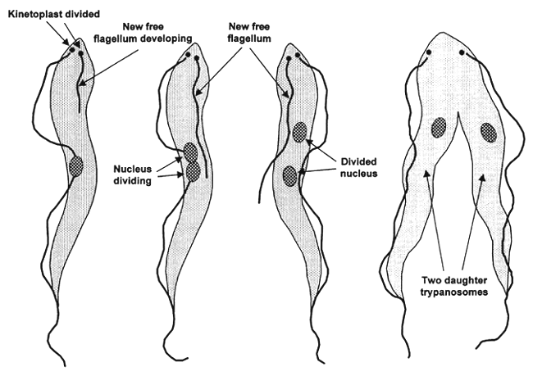

Differential morphology
There are distinct differences in appearance, shape and size between the various species of trypanosomes, allowing specific identification. It must be remembered, however, that in any biological material there is some variability. Also, trypanosomes are not rigid and continuously change their shape slightly; the individual parasite seen in the stained preparation presents the shape it had at the moment of dying. It has also been subjected to the unnatural stresses of drying out and being fixed and stained. Many variations in appearance are therefore seen, differing somewhat from the drawings in textbooks. It is thus necessary to observe carefully and systematically all the features in a sufficiently large number of individual trypanosomes; only after such an examination is it possible to arrive at a reasonably accurate diagnosis. There will be examples where trypanosomes are so few, or the staining so inadequate, that identification may not be possible or only after a prolonged search. It is also essential to examine several individual trypanosomes, because even if one specimen is sufficiently perfect to establish its identity beyond any doubt, further search may reveal another species and thus a mixed infection. Mixed infections occur more often in the field than was previously thought, as new more sensitive diagnostic techniques have shown (see Chapter 3 - Diagnosis).
For specific identification, a number of trypanosomes should be examined systematically for the presence or absence, size and position of a number of features:
- Presence or absence of trypanosomes of different appearance. If all individual trypanosomes are alike, the infection is called monomorphic (of one form); if there are distinctly different types it can be either a polymorphic (= pleiomorphic) species, or a mixed infection of different species.
- Presence or absence of a free flagellum. In certain species there may be some trypanosomes with, and some without, a free flagellum.
- Size of the trypanosome (expressed in μm).
- The size and position of the kinetoplast. The position is related to proximity to the posterior extremity (rear end) of the organism.
- The degree of development of the undulating membrane. It may be conspicuous or inconspicuous.
- The shape of the parasite, particularly the shape of its posterior part. The posterior extremity may vary from blunt to pointed.
It is important to remember that the successful use of this simple key depends on the presence in the preparation of a sufficient number of individual parasites. It is not always possible to make an accurate diagnosis if only one or two parasites can be found after a prolonged search. The task is rendered more difficult or even impossible if the stained preparation is of poor quality.

TAXONOMY AND NOMENCLATURE
Taxonomy is the classification and orderly arrangement of living organisms according to their structure and shape (morphology), their biological development (life cycles) and, more recently, their molecular structure, particularly that of their genome (molecular taxonomy). Nomenclature, the system of naming organisms, is based on their classification. Without going into great detail, let it be recalled that organisms are classified into large divisions called phyla (singular phylum), then into classes, orders and families. For example, the Diptera are an order of the class of insects, which belongs to the phylum of the arthropods, and the Glossinidae or tsetse flies are a family of the Diptera. The family Trypanosomatidae (which includes trypanosomes, but also for instance leishmanias) belongs to the order of the Kinetoplastida, the class Zoomastigophorea and the phylum Protozoa. Each species is furthermore given two names, the first, always spelled with a capital letter, places it in a relatively small group known as the genus (plural genera) and the last name, spelled with a small letter, indicates the species. The family Glossinidae comprises only one genus, Glossina, which includes over 20 species of tsetse flies. Sometimes a genus is subdivided into subgenera, and an additional name is sometimes added to denote a subspecies, when differences within one genus and/or species are so wide that a further breakdown is helpful (e.g. Trypanosoma [Trypanozoon] brucei gambiense, which is the causal agent of classical human sleeping sickness; details of this name will be explained a little further on). The genus (or subgenus), species (or subspecies) may be further defined by adding the surname of the person who first described it and the year when the description was published (e.g. Trypanosoma congolense Broden, 1904 indicates that Broden in 1904 published the first description of this important pathogenic trypanosome of cattle in tropical Africa).
Another subdivision of the genus Trypanosoma, into two sections, is mainly based on the way in which the infective forms leave the intermediate insect host after their cyclical development.
In the section Stercoraria, development in the vector ends with the formation of infective metatrypanosomes in the posterior part of the digestive tract and transmission occurs through the faeces of the insect,⁶ while in the Salivaria, with which we are mainly concerned in this field guide, the usual mode of transmission is inoculative, through the biting mouthparts of the vector (except for dourine).
In higher organisms a species is defined as a group of organisms that can interbreed with one another to produce fertile offspring. In the case of viruses, bacteria, and many of the protozoa, where no (classical) sexual processes are known to occur, the definition of species is more arbitrary and some scientists adhere to the principle that a valid species is one that is recognized by a good taxonomist. In addition to morphological and biological characteristics, molecular taxonomy is now increasingly used.
Once the identity of an organism has been stated in a scientific paper or book, it is customary to shorten the genus name to its initial capital letter and omit the name and year of the person who first described it (e.g. Trypanosoma congolenseBroden, 1904 becomes T. congolense.)
⁶ The Stercoraria include for example the species Trypanosoma cruzi, which causes human trypanosomosis in Central and South America, also called Chagas disease; although it may be of even greater importance as a human disease than African sleeping sickness, it has fortunately no economic impact on livestock production.

Taxonomy and nomenclature of trypanosomes
Trypanosomes are unicellular organisms (Phylum Protozoa) belonging to the genus Trypanosoma, the family Trypanosomatidae and the order Kinetoplastida. Many species of trypanosomes occur as parasites in a wide variety of animals, and even plants. For the purpose of this field guide we are concerned with those causing disease (the pathogenic trypanosomes) in domestic animals in Africa (African animal trypanosomosis = AAT). Some of these parasites have been spread by humans from Africa to other continents. For example, T. vivax had been introduced to the Americas, by the importation of West African cattle in the eighteenth and nineteenth centuries, and it is likely that T. evansi had already “escaped” from Africa far earlier by animal movements (in particular camels) between Africa and Asia.
Trypanosomes are blood parasites (haemoparasites), from the word haem = blood, which in the vertebrate host occur in the blood and tissue fluid and within that group are known as haemoflagellates, as they progress actively by the movement of the thread-like filament called flagellum.
The trypanosomes causing AAT belong to three subgenera, as shown in Table 1.⁷
⁷ A fourth subgenus, Pycnomonas, which comprises one species, T. suis, is a rare and poorly known parasite of pigs (and wild pigs such as wart hog), which we shall not mention any further.

Specific morphology
The subgenus Nannomonas (the congolense group). T. congolense (see Figure 3). This is the smallest of the pathogenic trypanosomes, with a length of 9–22 μm.
Figure 3
Trypanosoma congolense as seen in a stained blood smear
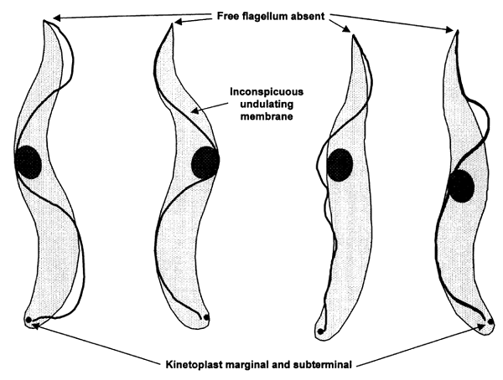
The blood forms are monomorphic, in that they lack a free flagellum (in the longer forms the shape of the anterior extremity may suggest the presence of a very short free flagellum). The use of the term monomorphic is somewhat misleading in this species in that there is a variation in size and shape between strains. Generally two variants are to be seen, a shorter form (9–18μ), the typical congolense type and a longer form (up to 25μ), with individuals intermediate in length between the two. The proportion of long and short forms varies in different cases and, it has been said, localities of origin. There is evidence which indicates that strains with the most long forms, the so-called “dimorphic” strains, cause a more severe form of trypanosomosis.
Recent studies have now resulted in a subdivision of the species in several “types”, which can be distinguished by isoenzymatic differences⁸ and molecular techniques.⁹ Only one type has received a separate species name, T. godfreyi (see below), as it is also different in its pathogenicity for various hosts, while the others are designated as T. congolense savannah type, T. congolense Tsavo type, T. congolense forest type, T. congolense Kilifi type. For the purpose of this practical field manual we shall use only the name of T. congolense for these four types, but it should be remembered that from a scientific point of view this name encompasses rather different parasites and possibly more than one species.
In stained specimens of T. congolense the cytoplasm stains a diffuse, even, pinkish colour and is seldom granular.
The nucleus is centrally placed. The kinetoplast is of medium size and is usually situated at the margin of the body, just in front of the posterior extremity (marginal and subterminal).
The undulating membrane is poorly developed and inconspicuous.
T. simiae (see Figure 4). Trypanosomes of this species are polymorphic, with a length of 12–24 μm. In typical cases some individuals are with and others without a free flagellum.
⁸ Isoenzymes may be defined as enzymes which have identical functions but show molecular differences that can be detected with appropriate techniques.
⁹ Such as those mentioned in Chapter 3 on diagnosis under molecular tests (DNA probes, PCR).
Figure 4
Trypanosoma simiae blood stream forms
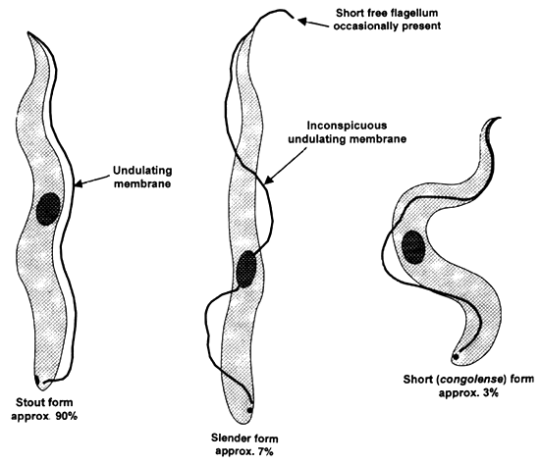
The kinetoplast is of medium size, marginal and subterminal, as in T. congolense. Three morphological types can be recognized:
- Long stout forms, some of which may possess a free flagellum. Most parasites present in natural infections belong to this type. The undulating membrane is conspicuous and well marked.
- Long slender forms, with sometimes a free flagellum, constitute a minority of the population. The undulating membrane is less prominent than in the preceding form.
- A few short forms also occur, and are indistinguishable from typical T. congolense. (They are often called “congolense forms”.)
T. godfreyi. This species has been separated recently from T. congolense in the Gambia, on the basis of isoenzymatic and DNA differences, but also because the disease it causes is different. It is pathogenic for pigs, but the disease is more chronic than the one caused by T. simiae. Morphologically it is similar to T. congolense, with a length of 9–22 μm (mean 13.7), but the undulating membrane is described as being usually conspicuous.
The wart hog appears to be its normal host and constitutes a reservoir of infection for domestic pigs.
The subgenus Duttonella (the vivax group). T. vivax (see Figure 5). This trypanosome as seen in the blood of mammals is also essentially monomorphic, with a free flagellum. Its length, including the free flagellum, varies from 18 to at least 26 μm. The following description concerns typical specimens.
The kinetoplast is large and terminal or almost so. It is much larger than in any of the other pathogenic species, and this is a distinguishing feature.
The nucleus is centrally placed, but the bulk of the cytoplasm is found in the posterior part of the body as this is somewhat swollen.
The posterior extremity is swollen and blunt.
Figure 5
Trypanosoma vivax blood stream forms
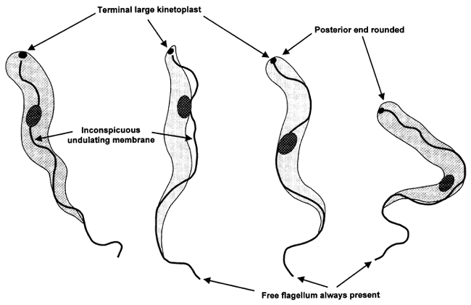
The undulating membrane is inconspicuous.
A more slender form is sometimes seen, which possesses a more pointed posterior extremity and has been thought to cause a more severe form of the disease. Such forms are commonly seen when T. vivax is dividing rapidly in the blood and it has also been reported that T. vivax in Latin America is more slender than the typical African parasite.
T. uniforme. Small trypanosomes (from 12 to 20 μm), otherwise similar to T. vivax, have been given the name T. uniforme. It is not recognized as a separate species by all specialists; some regard it as a subspecies (T. vivax uniforme).
The subgenus Trypanozoon (the brucei group). This group comprises five members: T. brucei brucei, T. brucei gambiense, T. brucei rhodesiense, T. evansi and T. equiperdum. The three subspecies of T. brucei are normally transmitted by tsetse flies (in contrast to T. evansi and T. equiperdum) and are exactly similar in morphology, but only T. brucei gambiense and T. brucei rhodesiense are the cause of human sleeping sickness, the former mainly in West and Central Africa and the latter in eastern and southern Africa. T. brucei brucei is not infective to humans.
T. brucei (see Figure 6). T. brucei is polymorphic, with three main forms, all of which have a small kinetoplast and a conspicuous undulating membrane:
- Long slender forms (23–30 μm in length) with a free flagellum, which may be up to one half of the length of the organism. The posterior end is pointed and the nucleus is central. The kinetoplast is placed up to 4 μm in front of the posterior extremity.
- Short stumpy forms (17–22 μm in length) normally without a free flagellum, but in which there may occasionally be individuals with a short free flagellum. The kinetoplast is usually subterminal. The position of the nucleus varies greatly and it is in some cases in the posterior part of the cell, sometimes so far posterior that the kinetoplast is anterior to it (so-called postero-nuclear forms). There is considerable variation in appearance between short stumpy forms, from broad, squat types (which include the postero-nuclear forms) to a form similar to T. congolense, although longer. In stained specimens blue volutin granules are often present in the cytoplasm, often arranged in a line along the margin of the cell.
- Intermediate forms, varying in length between the two previously mentioned types. A free flagellum, of varying length, is always present. The nucleus is centrally placed. The posterior end is somewhat variable in shape, but usually bluntly pointed. The kinetoplast is close to the posterior extremity. Volutin granules are occasionally present but neither as common nor as plentiful as in the short, stumpy forms.
Figure 6
Trypanosoma brucei blood stream forms
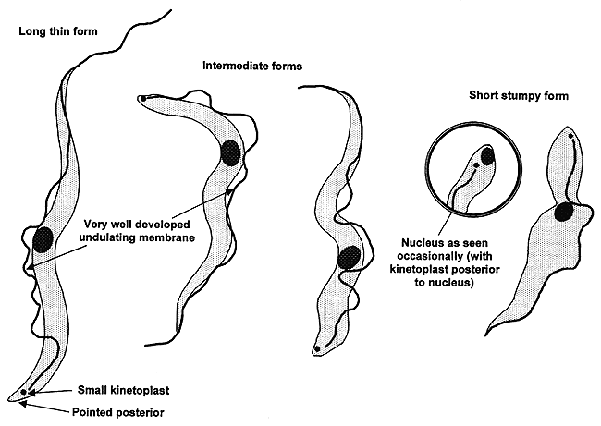
During the course of the infection, there is a change in the trypanosome population from the long thin forms, through the intermediate, to the short stumpy, and this altered appearance is accompanied by a change in the type of respiration, as the trypanosome prepares for its period within the tsetse fly. The short stumpy forms are adapted to living and developing in the tsetse, while long thin forms are the true mature blood forms which die in the gut of the insect. (Similar metabolic changes also occur in other trypanosome species, but there are no such obvious morphological changes associated with them as in T. brucei.)
As noted above, the species T. brucei is subdivided into three subspecies, T. brucei brucei, African trypanosome transmitted by tsetse flies, not infective to humans, T. brucei gambiense, the causal agent of classical or Gambian human sleeping sickness, and T. brucei rhodesiense, which causes the type of human sleeping sickness common in Zimbabwe.
T. evansi.¹⁰ T. evansi cannot be distinguished on morphological grounds from the long slender forms of T. brucei, and it is almost certain that T. evansi has developed from T. brucei by continual mechanical passage (particularly through camels), the vectors being blood-sucking flies, especially those of the Tabanid family. The disease, often called surra in Asia and by a variety of names elsewhere, such as el debab (northern Africa), mal de caderas (Brazil), murrina (Central America), has spread over a wide area outside the tsetse belts in Africa, in the Near East, India, China and Southeast Asia, as well as in tropical America. Direct mechanical transmission has resulted in T. evansi losing its ability to undergo the developmental cycle in tsetse flies.
Its length is from 17 to at least 30 μm, and the description given for the long slender forms of T. brucei fits T. evansi. Nevertheless, short stumpy and intermediate forms may be seen rarely, irregularly and in very small numbers, including posteronuclear forms. A greatly varying proportion of individual trypanosomes may have no visible kinetoplast and there are even strains of T. evansi in which the kinetoplast is not apparent in any individual trypanosome, the so-called akinetoplastic strains (such strains have in the past been considered in Latin America as a separate species, T. equinum, but this name is no longer considered valid).
T. equiperdum. This is another trypanosome which is probably derived from T. brucei. Its morphology is identical to that of T. evansi and the long slender forms of T. brucei, but it is different in that it causes a natural disease only in animals of the horse family (horse, donkey, mule), among which it is transmitted by genital contact. The disease, dourine, is thus a venereal disease. As it is not dependent on insect vectors, it has spread as far north as Canada, Russia and other European countries, and as far south as Chile and South Africa. (It has since been eradicated in many countries.)
¹⁰ Because this trypanosome is believed to be derived from T. brucei brucei, the name T. brucei evansi is sometimes used for it. Nevertheless, this particular trinomial name is invalid according to the rules of the international code for zoological nomenclature, as the name evansi was created before the name brucei. In order not to cause confusion, we will stick to using the commonly accepted species names of T. brucei and T. evansi.
T. theileri and other species of the subgenus Megatrypanum (Stercoraria). T. theileri in cattle, domestic buffalo and various wild Bovidae (members of the family of bovines), and also related species such as T. ingens (antelopes and cattle), are normally non-pathogenic and only concern us because they can confuse the parasitological diagnosis of trypanosomosis. T. theileri is a cosmopolitan species (occurring all over the world), transmitted by tabanid flies and probably also by ticks. It is a large species (from some 30 to over 60, even 100 μm), normally very scanty in the peripheral blood, but it is encountered relatively frequently by careful observers. Its large size and its morphology are distinctive features. In stained smears it cannot be confused with the pathogenic species, because of its large size, the position of the kinetoplast (far from the posterior extremity), and its finely pointed posterior extremity. Even in the buffy coat, its large size and sluggish movements often allow the diagnosis of Megatrypanum sp. Of the other species of Megatrypanum only T. ingens is also sometimes found in cattle; it is also an unmistakable huge trypanosome, deeply staining with Giemsa, and with a typical band-like transverse nucleus. (Non-pathogenic species of Megatrypanum also occur in sheep and goats, but they are so seldom encountered in blood preparations that we will not discuss them.)

Causes
Sleeping sickness is caused by two germs (protozoa), Trypanosoma brucei rhodesiense and Trypanosomoa brucei gambiense . The more severe form of the illness is caused by T. b. rhodesiense .
Tsetse flies carry the infection. When an infected fly bites you, the infection spreads through your blood.
Risk factors include living in parts of Africa where the disease is found and being bitten by tsetse flies. The disease does not occur in the United States. But travelers who have visited or lived in Africa can have the infection.

Back to TopSymptoms
General symptoms include:
- Anxiety
- Drowsiness during the day
- Fever
- Headache
- Insomnia at night
- Mood changes
- Sleepiness (may be uncontrollable)
- Sweating
- Swollen lymph nodes all over the body
- Swollen, red, painful nodule at site of fly bite
- Weakness

Back to TopTreatment
Medicines used to treat this disorder include:
- Eflornithine (for T. b. gambiense only)
- Melarsoprol
- Pentamidine (for T. b. gambiense only)
- Suramin (Antrypol)
- Some patients may receive combination therapy

Back to TopPrevention
Pentamidine injections protect against T. b. gambiense. But not againstT. b. rhodesiense . Because this medicine is toxic, using it for prevention is not recommended.
Insect control measures can help prevent the spread of sleeping sickness in high-risk areas.

