B.Sc. Zoology Paper III
Dr. B. L. Gupta
Department of Zoology

SPERMATOGENESIS
Spermatogenesis is the production of sperm from the primordial germ cells. Once the vertebrate PGCs arrive at the genital ridge of a male embryo, they become incorporated into the sex cords. They remain there until maturity, at which time the sex cords hollow out to form the seminiferous tubules, and the epithelium of the tubules differentiates into the Sertoli cells. The initiation of spermatogenesis during puberty is probably regulated by the synthesis of BMP8B by the spermatogenic germ cells, the spermatogonia. When BMP8B reaches a critical concentration, the germ cells begin to differentiate. The differentiating cells produce high levels of BMP8B, which can then further stimulate their differentiation. Mice lacking BMP8B do not initiate spermatogenesis at puberty
The spermatogenic germ cells are bound to the Sertoli cells by N-cadherin molecules on both cell surfaces and by galactosyltransferase molecules on the spermatogenic cells that bind a carbohydrate receptor on the Sertoli cells. The Sertoli cells nourish and protect the developing sperm cells, and spermatogenesis—the developmental pathway from germ cell to mature sperm—occurs in the recesses of the Sertoli cells. The processes by which the PGCs generate sperm have been studied in detail in several organisms, but we will focus here on spermatogenesis in mammals.
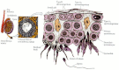

Drawing of a section of the seminiferous tubule, showing the relationship between Sertoli cells and the developing sperm. As cells mature, they progress toward the lumen of the seminiferous tubule.
After reaching the gonad, the PGCs divide to form type A₁ spermatogonia. These cells are smaller than the PGCs and are characterized by an ovoid nucleus that contains chromatin associated with the nuclear membrane. The A₁spermatogonia are found adjacent to the outer basement membrane of the sex cords. They are stem cells, and at maturity, they are thought to divide so as to make another type A₁ spermatogonium as well as a second, paler type of cell, the type A₂ spermatogonium. Thus, each type A₁ spermatogonium is a stem cell capable of regenerating itself as well as producing a new cell type. The A₂ spermatogonia divide to produce the A₃ spermatogonia, which then beget the type A₄ spermatogonia. It is possible that each of the type A spermatogonia are stem cells, capable of self-renewal. The A₄spermatogonium has three options: it can form another A₄ spermatogonium (self-renewal); it can undergo cell death (apoptosis); or it can differentiate into the first committed stem cell type, the intermediate spermatogonium. Intermediate spermatogonia are committed to becoming spermatozoa, and they divide mitotically once to form the type B spermatogonia. These cells are the precursors of the spermatocytes and are the last cells of the line that undergo mitosis. They divide once to generate the primary spermatocytes—the cells that enter meiosis. It is not known what causes the spermatogonia to take the path toward differentiation rather than self-renewal; nor is it known what stimulates the cells to enter meiotic rather than mitotic divis
During the spermatogonial divisions, cytokinesis is not complete. Rather, the cells form a syncytium whereby each cell communicates with the others via cytoplasmic bridges about 1 μm in diameter. The successive divisions produce clones of interconnected cells, and because ions and molecules readily pass through these intercellular bridges, each cohort matures synchronously. During this time, the spermatocyte nucleus often transcribes genes whose products will be used later to form the axoneme and acrosome.

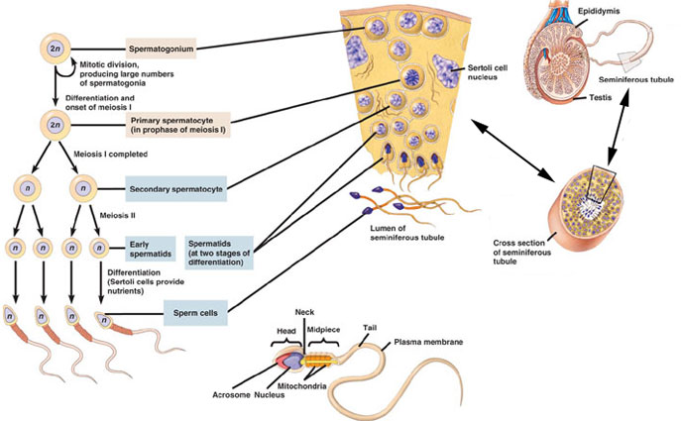
The formation of syncytial clones of human male germ cells.
Each primary spermatocyte undergoes the first meiotic division to yield a pair of secondary spermatocytes, which complete the second division of meiosis. The haploid cells thus formed are called spermatids, and they are still connected to one another through their cytoplasmic bridges. The spermatids that are connected in this manner have haploid nuclei, but are functionally diploid, since a gene product made in one cell can readily diffuse into the cytoplasm of its neighbors. During the divisions from type A₁ spermatogonium to spermatid, the cells move farther and farther away from the basement membrane of the seminiferous tubule and closer to its lumen. Thus, each type of cell can be found in a particular layer of the tubule. The spermatids are located at the border of the lumen, and here they lose their cytoplasmic connections and differentiate into sperm cells. In humans, the progression from spermatogonial stem cell to mature sperm takes 65 days.

SPERMIOGENESIS
The mammalian haploid spermatid is a round, unflagellated cell that looks nothing like the mature vertebrate sperm. The next step in sperm maturation, then, spermiogenesis (or spermateliosis), the differentiation of the sperm cell. For fertilization to occur, the sperm has to meet and bind with the egg, and spermiogenesis prepares the sperm for these functions of motility and interaction. The first steps involve the construction of the acrosomal vesicle from the Golgi apparatus. The acrosome forms a cap that covers the sperm nucleus. As the acrosomal cap is formed, the nucleus rotates so that the cap will be facing the basal membrane of the seminiferous tubule. This rotation is necessary because the flagellum is beginning to form from the centriole on the other side of the nucleus, and this flagellum will extend into the lumen. During the last stage of spermiogenesis, the nucleus flattens and condenses, the remaining cytoplasm (the “cytoplasmic droplet”) is jettisoned, and the mitochondria form a ring around the base of the flagellum.
One of the major changes in the nucleus is the replacement of the histones by protamines. Transcription of the gene for protamine is seen in the early haploid cells (spermatids), although translation is delayed for several days . Protamines are relatively small proteins that are over 60% arginine. During spermiogenesis, the nucleosomes dissociate, and the histones of the haploid nucleus are eventually replaced by protamines. This causes the complete shutdown of transcription in the nucleus and facilitates its assuming an almost crystalline structure. The resulting sperm then enter the lumen of the tubule.
In the mouse, the entire development process from stem cell to spermatozoon takes 34.5 days. The spermatogonial stages last 8 days, meiosis lasts 13 days, and spermiogenesis takes up another 13.5 days. In humans, spermatic development takes nearly twice as long to complete. Because the type A₁ spermatogonia are stem cells, spermatogenesis can occur continuously. Each day, some 100 million sperm are made in each human testicle, and each ejaculation releases 200 million sperm. Unused sperm are either resorbed or passed out of the body in urine. During his lifetime, a human male can produce 10¹² to 10¹³ sperm.
SERTOLI CELLS

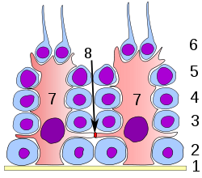
At all stages of differentiation, the spermatogenic cells are in close contact with Sertoli cells which are thought to provide structural and metabolic support to the developing sperm cells. A single Sertoli cell extends from the basement membrane to the lumen of the seminiferous tubule, although the cytoplasmic processes are difficult to distinguish at the light microscopic level.
Sertoli cells serve a number of functions during spermatogenesis, they support the developing gametes in the following ways:
- Maintain the environment necessary for development and maturation, via the blood-testis barrier
- Secrete substances initiating meiosis
- Secrete supporting testicular fluid
- Secrete androgen-binding protein (ABP), which concentrates testosterone in close proximity to the developing gametes
- Testosterone is needed in very high quantities for maintenance of the reproductive tract, and ABP allows a much higher level of fertility
- Secrete hormones affecting pituitary gland control of spermatogenesis, particularly the polypeptide hormone, inhibin
- Phagocytose residual cytoplasm left over from spermiogenesis
- Secretion of anti-Müllerian hormone causes deterioration of the Müllerian duct.
- Protect spermatids from the immune system of the male, via the blood-testis barrier

Hormonal control of spermatogenesis
Hormonal control of spermatogenesis varies among species. In humans the mechanism is not completely understood; however it is known that initiation of spermatogenesis occurs at puberty due to the interaction of the hypothalamus, pituitary gland and Leydig cells. If the pituitary gland is removed, spermatogenesis can still be initiated by follicle stimulating hormone (FSH) and testosterone. In contrast to FSH, LH appears to have little role in spermatogenesis outside of inducing gonadal testosterone production.
FSH stimulates both the production of androgen binding protein (ABP) by Sertoli cells, and the formation of the blood-testis barrier. ABP is essential to concentrating testosterone in levels high enough to initiate and maintain spermatogenesis. Intratesticular testosterone levels are 20–100 or 50–200 times higher than the concentration found in blood, although there is variation over a 5- to 10-fold range amongst healthy men. FSH may initiate the sequestering of testosterone in the testes, but once developed only testosterone is required to maintain spermatogenesis. However, increasing the levels of FSH will increase the production of spermatozoa by preventing the apoptosis of type A spermatogonia. The hormone inhibin acts to decrease the levels of FSH. Studies from rodent models suggest that gonadotropins (both LH and FSH) support the process of spermatogenesis by suppressing the proapoptotic signals and therefore promote spermatogenic cell survival.
The Sertoli cells themselves mediate parts of spermatogenesis through hormone production. They are capable of producing the hormones estradiol and inhibin. The Leydig cells are also capable of producing estradiol in addition to their main product testosterone. Estrogen has been found to be essential for spermatogenesis in animals. However, a man with estrogen insensitivity syndrome (a defective ERα) was found produce sperm with a normal sperm count, albeit abnormally low sperm viability; whether he was sterile or not is unclear. Levels of estrogen that are too high can be detrimental to spermatogenesis due to suppression of gonadotropin secretion and by extension intratesticular testosterone production. Prolactin also appears to be important for spermatogenesis.

